**The University of the West Indies**

**Department of Computing and Information Technology**

**INFO 3604 Project Course**

**Project Implementation**

**Project Name:** Center of Activity for Students

**Project Members:**

* Joshua Oxley
* Geraldine Marcano
* Kenaird Saunders

**Architectural Design:**

The component diagram below depicts the major components that the CAS project would be made of and a description of the components purpose.

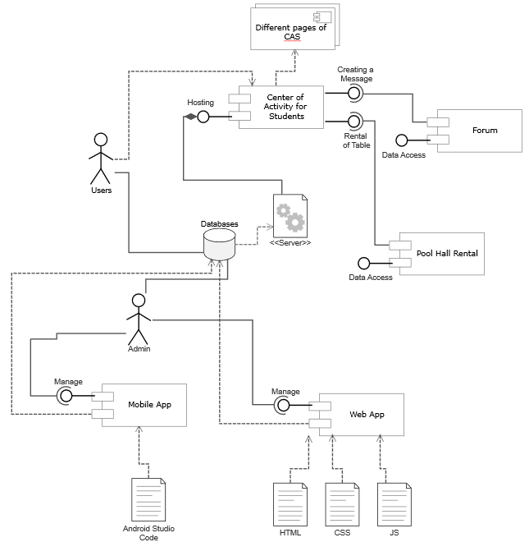

Diagram 1: Component Diagram for CAS

The CAS component is the completed project available for Users to utilize.

The Mobile App is a method for users to access CAS using a mobile device and the admin to make updates to the application.

The Web App is the main method of access to the CAS system for users and the admin can update the application.

The different Pages of CAS are the various pages that would make up the CAS displays.

The Forum is where Users would converse with other Users about The UWI or any inquiries that they may have.

The Pool Rental Hall is where Users would rent a table for a set time to utilize the facilities.

**Class Diagram:**

The Class diagram depicts the main classes that would make up the projects systems including the attributes, methods and relationship with each other within the system.

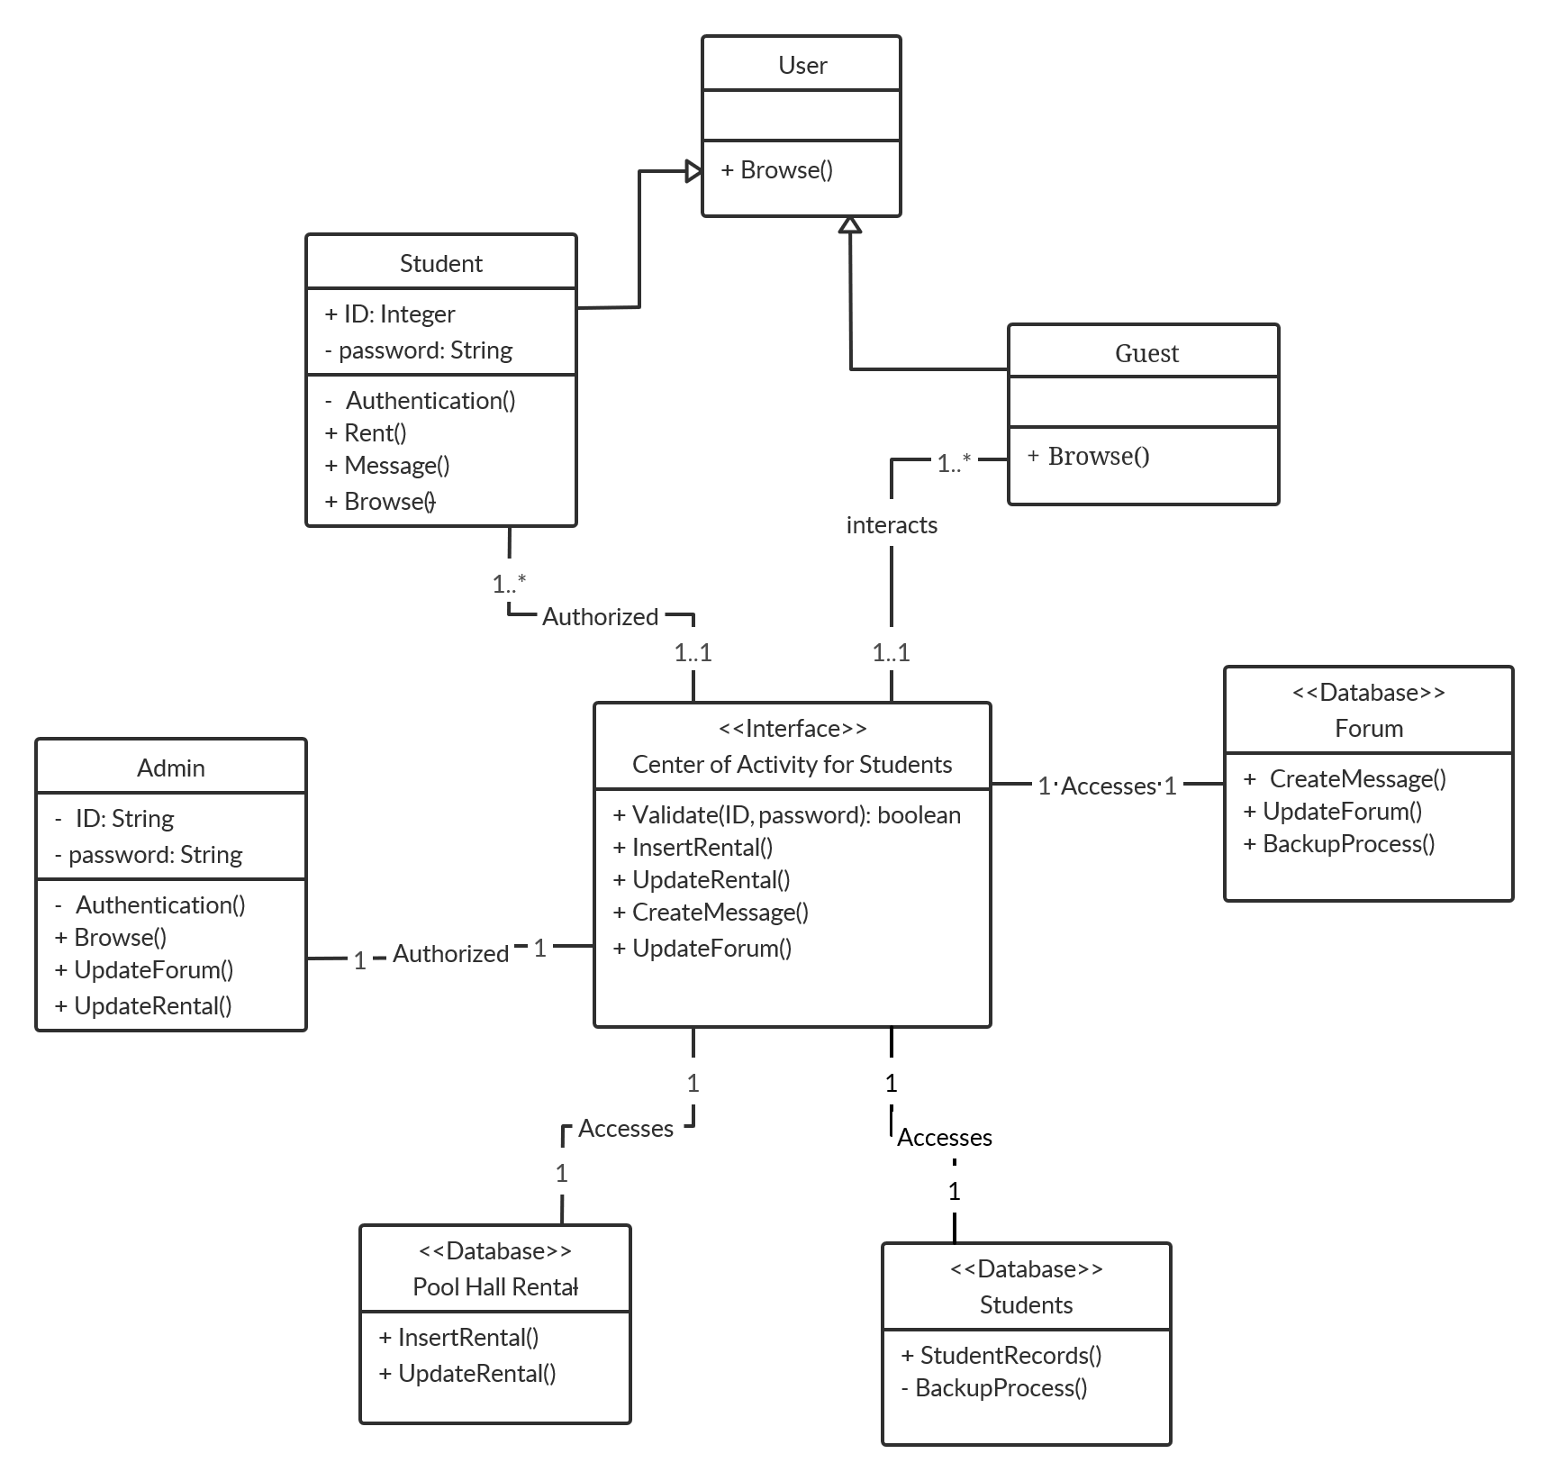

Diagram 2: Class Diagram for CAS

**Entity Relationship Model:**

This ERD depicts the relationships of the core entities that make up the CAS system.

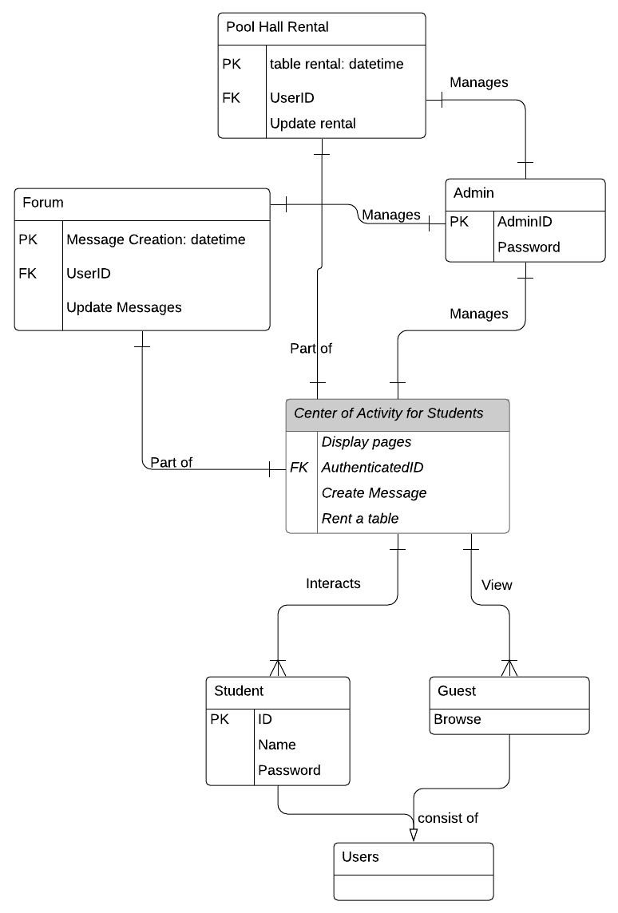

Diagram 3: Entity relationship diagram for CAS

**Sequence Diagram:**

The diagram depicts the interactions of the users and the major component in the sequence of their interactions in the system.

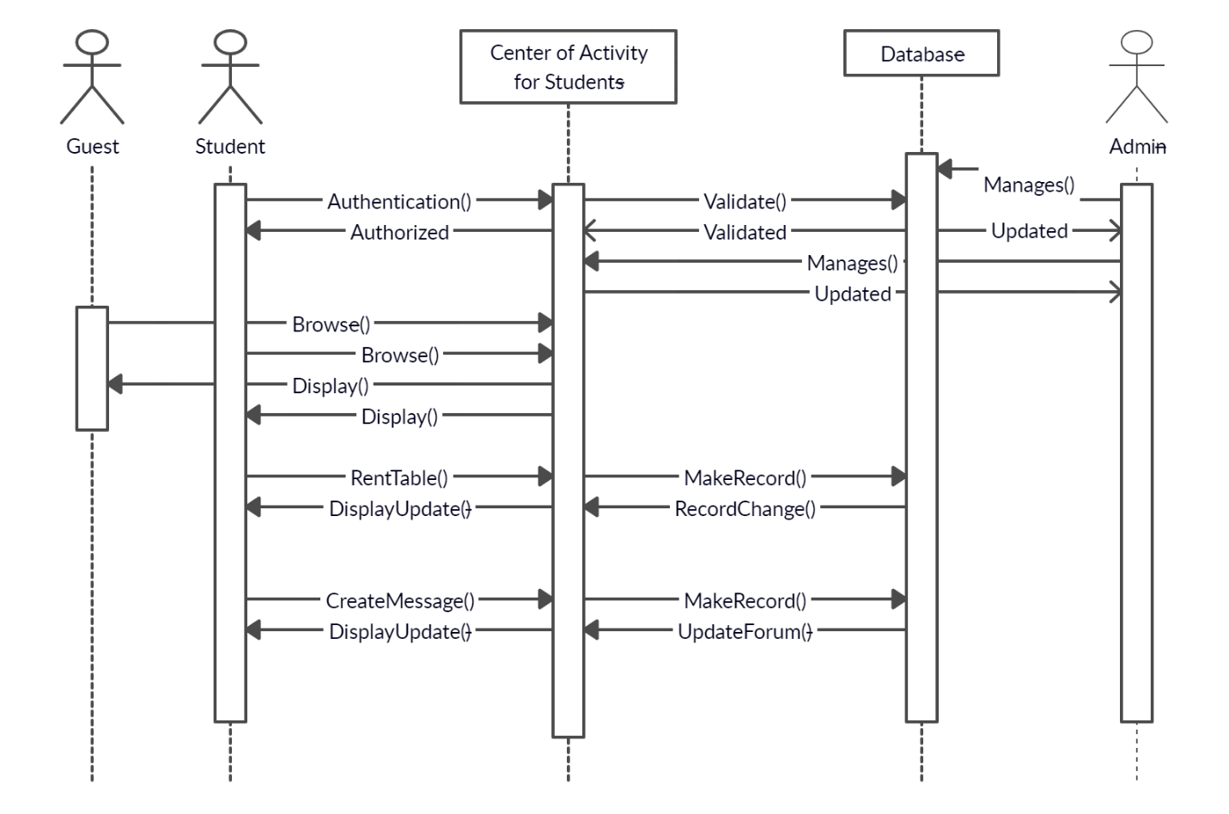

Diagram 4: Sequence Diagram for CAS

**Description of Technology Used:**

Hardware devices:

* Laptops – to code and carry out project deadlines, to test the web application
* Smartphones – to keep in touch with the availability of information as well as the testing of the mobile app.

Software products:

* GitHub - used to store and host the documentation and CAS system components
* phpMyAdmin – is used for the database hosting site
* MySQL – manages the database
* WAMP – used for development and internal testing
* Lucid Charts – used to create the diagrams
* Creately – used to create the diagrams
* Snipping tool – for cropping images needed
* Android Studio Code – utilized to create the mobile application
* Visual Studio Code - is used to create the web application.
* Microsoft Word – used to make project reports, milestones and documentation

Programming languages:

* HTML, JS and CSS are utilized in the creation of the web pages.
* Java is the coding language used to create the mobile application.
* PHP is used for the connection of the databases and the CAS system.

**Glossary**

MVC - Model-View Controller

JS - Java Script

HTML- Hyper Text Markup Language

CSS - Cascading Style Sheet

WAMP – Windows, Apache, MySQL, PHP

CAS – Center of Activity for Students

ERD – Entity Relationship Diagram